**Domesticating the wild: aquaculture escapees increase catches of two iconic Mediterranean fish**

Kilian Toledo-Guedes, Tim Dempster, David Izquierdo, Javier Atalah, Damián Fernandez-Jover, Ingebrigt Uglem, Pablo Arechavala-Lopez, and Pablo Sanchez-Jerez.

**Abstract**

Extractive fisheries and marine aquaculture share both space and target species. Several regional-scale examples exist of escapees entering wild fisheries, yet no study has assessed the influence of aquaculture on fisheries landings at ecosystem scale. Using FAO time series data spanning 70 years for fisheries landings and 30 years for landings per unit of effort (LPUE) of European seabass (*Dicentrarchus labrax*) and Gilthead seabream (*Sparus aurata*) and published rates of escape, we tested if the introduction of aquaculture of these species altered fisheries. Fisheries landings and the number of aquaculture escapees entering the wild were strongly correlated; 65% of catch variability for both species was explained by the amount of escapees, with a stronger relationship for LPUE variability for seabream (80.7%). Positive shifts in fisheries landings were detected for both species, matching the moment aquaculture began in the Mediterranean (1970-74) and the period when estimated escapees from aquaculture surpassed fisheries landings (1995-99). The addition of escapees to the wild has likely masked overexploitation of wild stocks, confounded stock assessments and modified the genetic diversity of these two species in the wild.

Lubina mortality, capturability, leakeage

**Keywords:** *European seabass, Gilthead seabream,* escape events, stock assessments.

**Introduction**

Extractive fisheries are suffering a worldwide decline in landings (Pauly et al. 2016), caused by depletion and overfishing, which affects 68% of fish stocks (Costello et al. 2016). Despite declining wild catches, total consumption of fish by humans is projected to rise by 27% from 2010-2030 (World Bank 2013). Aquaculture is viewed by many as vital to fill much of the unmet demand (Marra 2005; Duarte et al. 2009) and has grown 8% per year since 1980 (FAO 2014).

Global patterns are largely mirrored in the Mediterranean Sea, with 52% of assessed fish stocks considered overexploited (FAO 2014). Overfishing, combined with other human impacts (e.g. habitat loss, exotic species) in the semi-closed Mediterranean Sea, has led to the decline of several fish stocks (Vasilakopoulos et al. 2014). In contrast, aquaculture has grown rapidly over the past decades. It relies heavily on high and medium trophic level species (i.e. finfish), leading to the process of ‘farming up’ marine food webs (Stergiou et al. 2008). Extractive fisheries and finfish mariculture in the Mediterranean share the same target species. Gilthead seabream (*Sparus aurata*) and European seabass (*Dicentrarchus labrax*) are important fisheries species and the most farmed finfish. Combined annual aquaculture production now exceeds 250000 tons, while catches from wild fisheries are < 4000 tons (FAO 2014). At any given time, approximately 400-500 million fish of each species are held in over 20,000 floating cages across the Mediterranean (Trujillo et al. 2012).

Where farmed and wild species coexist, a range of interactions is possible, principally through the entry of escaped fish into wild populations. Escapees have trophic interactions with wild assemblages (Lorenzen et al. 2012), alter the genetic composition of wild populations (Glover et al. 2013a) and can spread parasites and diseases (Glover et al. 2013b). While the extent of escapes across the Mediterranean is unknown, evidence suggests that escape events are widespread and significant. An analysis of escapes across three Mediterranean countries over three years estimated that 7.65 million juvenile and adult fish had escaped (Jackson et al. 2016). In addition, one million 1-year-old seabreams are estimated to recruit to wild populations in Greece each year via spawning within sea-cages (‘escape through spawning’; Somarakis et al. 2013).

The number of escapees entering wild populations may be sufficiently substantial to alter the trajectories of fisheries landings. Direct, local-scale assessments that have differentiated escaped and wild individuals reveal that between 20 and 70% of all seabream and seabass are escapees in areas where wild populations exist (Brown et al., 2015; Izquierdo-Gomez et al., 2017), being this figures exacerbated in case of massive escapes. Meanwhile, 100% of both species’ landings are farmed individuals in those areas where they are locally absent (Toledo-Guedes et al. 2014a, Izquierdo-Gomez and Sanchez-Jerez 2016). Further, a long-term data set shows that seabream landings have doubled in the Messolonghi lagoon, Greece after seabream aquaculture was introduced (Dimitriou et al. 2007). Whether these local-scale effects translate to a wider Mediterranean-scale impact on fisheries of these two iconic species is unknown.

Here, we tested if escapees from aquaculture into the Mediterranean Sea have influenced fisheries at ecosystem scale. Through analysis of long-term fisheries landings and landings per unit effort data for the Mediterranean Sea, combined with documented rates of escape of seabream and seabass, we assessed the extent to which fisheries have changed after the recent and rapid expansion of aquaculture in the region.

**Material and Methods**

*Study area and fisheries and aquaculture datasets*

We used the FAO time series data on aquaculture production and capture fisheries of seabream and seabass in the Mediterranean and the Black Sea area between 1950 and 2020 (FAO 2015). This area was selected because it is an extensive semi-closed system (i.e. escaped fish would not emigrate from the system in significant numbers) and is the most important area for seabass and seabream aquaculture (FAO 2014).

Data on fishing effort were not available for the entire Mediterranean. Therefore, yearly fleet size was extracted from the fleet register of the European Union (European Union 2013) for six Mediterranean states (Spain, France, Slovenia, Greece, Malta and Cyprus). Italy was excluded from all analyses due to a large anomaly detected between 2004 and 2005. During that year, catches of seabass in Italy decreased from 3,318 (61% of the total Mediterranean captures) to 156 tonnes, and seabream dropped from 3349 (46% of the Mediterranean captures that year) to 265 tonnes, and kept those low landing values for the subsequent years. Disruption in data series from 2005 is a consequence of changes in the Italian data collection system (FAO 2012). For small countries (i.e. Malta, Cyprus and Slovenia) that entered the fleet register in 2005, the number of vessels was extended back to avoid the noise created when a significant number of vessels enter the census, which artificially raises the number of vessels and, in turn, fishing effort.

The small-scale vessel fleet is the most important fleet targeting seabream and seabass. This fleet is most influenced by escapees since 80% of farms are close to the shore (Trujillo et al. 2012) and escapees of both species move into natural coastal habitats (Arechavala-Lopez et al. 2011, 2012). Thus, only small-scale vessels (i.e. not registered as trawlers or purse seiners) based in Mediterranean home ports were extracted and fleet size was used as a proxy for fishing effort. Then landings of the six countries (Spain, France, Slovenia, Greece, Malta and Cyprus) were pooled by species and divided by the small-scale fleet as a proxy for landings per unit of effort (hereafter LPUE). The latter dataset comprised 23 years, from 1990 to 2013.

*Estimated rates of escape*

Escape rates were derived from Jackson et al. (2015), who investigated escape events across three Mediterranean seabream- and seabass-producing countries (Spain, Greece and Malta) between 2009 and 2012. Fifty-two escape events led to 6.84 million escaped seabreams, while 15 events resulted in 0.6 million escaped seabass. Using the production data for the countries where the fish escaped, we estimated annual escape rates of 9.6% and 0.6% for seabream and seabass, respectively. In addition,, Toledo-Guedes (2014b ) estimated that the escape rate of seabass in the Canary Islands reached 5 % in years when large storms caused mass escape events (Toledo-Guedes 2014b). As uncertainty exists in the rate of escape through space and time, we used three escape rate scenarios for these two species: 1, 2.5 and 5%. For two reasons, the range of escape rates we used is likely conservative. As most escapees detected by Jackson et al. (2015) were caused by farm structures failure during storms, these figures do not fully account for difficult to detect ‘leaky escape’ events when fish escape through small holes in the nets. Moreover, they do not account for the similarly difficult to detect process of ‘escape through spawning’, which is a significant source of entry to the wild of farmed seabream (Somarakis et al. 2013).

*Statistical analyses*

We assessed temporal trends of seabream and seabass aquaculture production and fisheries landings in the Mediterranean. The estimated total amount of escapees were compared with fisheries landings to determine if and when escaped fish biomass surpassed wild fish biomass from fisheries landings. We used Granger test to

We used a regime shift index (RSI) combined with an automatic sequential algorithm (Rodionov 2004) to assess the existence, timing, and significance (α=0.05) of abrupt changes in standardised anomalies in fisheries landings and LPUE data. Anomalies were calculated for each yearly value by subtracting the mean and dividing by the standard deviation for the analysed period. This is a sequential processing technique; for each new observation, the test examines the validity of a null hypothesis being, the existence of a regime shift. The absolute value of RSI represents the magnitude of the shift(s), while its sign (+ or -) indicates an increase or decrease between regimes (Rodionov 2004).

Trends in stock abundances are usually detected by analysing catch or landings per unit of effort rather than pure catch or landings data (Watson and Pauly 2001). However, it has been argued that trends in catch data are consistent with biomass trends (Froese et al. 2012). Using landings data from all the Mediterranean countries guarantees that the patterns detected are not an artefact produced by the sampling scheme or records changes for a specific country. Regarding fishing effort, the present analysis assumes that there have not been significant inter-annual changes in species targeting within the respective fleets.

**Results**

Fisheries landings of seabream in the Mediterranean increased from 1950-2013. Seabass landings increased from 1950-2006 but declined thereafter (Fig. 1a, b). Aquaculture production of both species constantly grew from the 1990s (Fig. 1a, b). Estimated seabass escapees (669 t) surpassed fisheries landings (612 t) for the first time in 1994 (Fig. 1c). These events were delayed for seabream since values of estimated escapees (3,527 t) reached Mediterranean fisheries landings (3,393 t) in 2000 (Fig. 1d). It can be estimated that around 70,000 t of seabass and 83,000 t of seabream had escaped since 1970 when the culture of these species was established, until 2013. Of those amounts, 6,697 tonnes of seabass and 7,348 tonnes of seabream were released into the wild during 2013, which represents 4.4 (for seabass) and 1.6 (for seabream) times the fisheries catches for that.year (Fig. 1c, d).

Estimated escapees and total fisheries landings were significantly related for both species (p = 0.04 and p = 0.01, Fig. 2a, b). Yearly tonnes of escaped fish explained 34% and 42% of the variability in fisheries landings of seabass and seabream, respectively (Fig. 2a, b). A stronger relationship was found between estimated escapees and LPUE for seabream (pseudo-R2 = 0.69; Fig. 2d), while a non-significant positive trend was found between LPUE and estimated escapees of seabass (pseudo-R2 = 0.11 and p = 0.46, Fig. 2c).

Regime shift analysis (RSI) detected two positive shifts in standardised landings anomalies for seabass in 1973-74 (+0.72) and 1995-96 (+1.39), and seabream in 1973-74 (+1.01) and 1998-99 (+1.34; Fig. 3a). A positive shift occurred for standardised anomalies in seabream LPUEs in 2003-04 (+1.71; Fig. 3b). However, seabass LPUE was highly variable through time and no change was detected (Fig. 3b).

**Discussion**

Our Mediterranean-level analysis provides strong correlative evidence that wild catches of two iconic fish species are now driven by aquaculture. Given the overall decline in landing weights by the small-scale vessel fleet across the Mediterranean (between 2006 and 2012, the Mediterranean-Black Sea fish landing weight decreased by 20-30%; reference) and the absence of other major changes to the ecosystem such as increased primary productivity (reference), the most parsimonious explanation for the recent and rapid increase in seabream and seabass landings is that escaped fish from aquaculture boost wild populations. Our results have major implications for stock assessments, which will be continuously confounded by escapees, and the genetic diversity of these species in the wild. High connectivity levels between wild and farmed populations may also contribute to epidemics of pathogens or parasites (Arechavala et al. AEI).

Theoretically, aquaculture could alter fisheries captures in two ways: (1) fish escaping from aquaculture enhance stocks of wild conspecifics, thus maintaining and increasing captures; and (2) cheaper farmed fish flood the market, rendering wild fisheries non-profitable and thus relaxing fishing pressure (Villasante et al., 2013). Market flooding has only occurred in the short term (Valderrama and Anderson, 2010), as wild and farmed fish behave as two different, unrelated products (Villasante et al., 2013). Together with the multi-specific nature of Mediterranean fisheries (Lleonart and Maynou, 2003), this prevents this effect. However, aquaculture escapees increase wild fisheries landings at a regional scale (Dimitriou et al., 2007; Toledo-Guedes et al., 2014; Glamuzina et al., 2014; Arechavala-Lopez et al., 2015; Izquierdo-Gomez and Sanchez-Jerez, 2016). Our analysis reflects the additive effect of many local cases across the Mediterranean Sea.

Escapees could mask the overexploitation of wild stocks (Tsikliras et al., 2015), promoting misleading stock assessments. Seabream and seabass are important in Mediterranean demersal fisheries and are heavily exploited (FAO, 2011b). Before the introduction of aquaculture, seabream stocks were fished at levels above sustainable yield (Farrugio and Le Corre, 1994), and it is unlikely that this situation has improved (FAO, 2011b). Wild *Dicentrarchus labrax* is also fully exploited (FAO, 2005).

The biomass of species reared in floating cages in the Mediterranean massively surpasses that of wild populations, and estimated escapees are well above fisheries landings. This also happens, for instance, with Atlantic salmon (*Salmo salar*) but at a scale several orders of magnitude larger (Naylor et al., 2005). Shifts found for fisheries landings matched the beginning of aquaculture activity in the Mediterranean in the 1970s and the period during which estimated escapees surpassed fisheries landings (1995-99) for both species (Fig. 3a). In the case of LPUE, the positive shift detected for seabream in 2003-04 when estimated escapees are surpassing fisheries landings of the same species. However, while stock assessments for Atlantic salmon are reliable due to relatively easy and accurate discrimination between wild and escaped individuals (Fiske et al., 2005), seabream and bass escapees could be maintaining fisheries landings irrespective of the actual state of the wild stocks, since existing tools to identify farm-origin fish are not yet applied (Arechavala-Lopez et al., 2013b; Warren-Myers et al., 2015). Additionally, stock assessments in the Mediterranean and fisheries management are carried out through regional and national level policies since it is multi-specific and has a wide variety of gears (Smith and Garcia, 2014) which add complexity when handling escapees. For the first time, it is shown that escapees could influence fisheries landings at a pan-Mediterranean scale, highlighting an urgent necessity to separate wild and escaped stocks.

Most restocking programs use hatchery-produced fish (Araki et al., 2007); thus, escape events may be defined as ‘unplanned restocking actions’ (i.e. unintentional and non-controlled release of cultured fish). How suitable farmed fish are in maintaining and improving wild fish populations remains unclear (Araki and Schmid, 2010). Some studies point out that the use of farmed fish, generally with low genetic diversity, to restock small wild populations can cause introgression and loss of local adaptations, which could end in local extinctions due to genetic drift and bottlenecks (Youngson et al., 2001; Baskett et al., 2013). Both seabream and bass are well established in the Mediterranean; in the case of seabass, its population is divided into three main genetic groups: the North-Eastern Atlantic, the Western Mediterranean and the Eastern Mediterranean (Haffray et al., 2007). However, Mediterranean haplotypes have been detected as far as the Thames estuary and Norway (Coscia and Mariani, 2011), which is explained by the common use of Mediterranean hatchery strains in the Atlantic. A recent study has also suggested genetic admixture between wild and farmed seabass in Cyprus, where at some locations, escapees represent up to 70% of the individuals captured in the wild (Brown et al., 2015). Regarding seabream, the genetic distinction is detected between Atlantic and Mediterranean populations (Sola et al., 2007), and potential genetic admixture between farmed escapees and wild populations has already been pointed at regional level (Šegvić-Bubić et al., 2014). Consequently, a continuous escape-mediated restocking of wild populations could affect the genetic landscape and dilute local adaptations in both species, which may compromise the sustainability of the wild stocks in the long term (Youngson et al., 2001). Moreover, unlikeproper restocking actions, parasites and diseases are not monitored during escape events, posing a potential spreading risk (Arechavala-Lopez et al., 2013a).

Consumers also have concerns that aquaculture escapees are not labelled correctly (European Commission, 2013). Mislabelled escaped fish (i.e. farmed fish) can be sold as wild fish in local markets because discriminating tools are not applied (Arechavala-Lopez et al., 2013b). This way, food security could be compromised due to the antibiotic concentration that recent escapees, previously subjected to treatment, could carry (Juan-García et al., 2007). On the other hand, commercial and recreational fisheries can take advantage of escape events, which can be seen as positive events in the short term. In the case of commercial fisheries, escapees may suppose an extra income for the fishermen, and, for recreational fishermen, escape events may enhance their fishing experience, boosting their captures (Lorenzen et al., 2012). It seems clear that, together with natural mortality, both professional and recreational fisheries play an important role in removing escapees from the wild (Toledo-Guedes et al., 2014), being advised its inclusion in future contingency plans to recapture escapees as it occurs in other producing countries, which have developed specific regulation for escape events, in a general legal framework for aquaculture activities (all links to regulations in Izquierdo-Gomez et al., 2015).

There is a clear need to develop measures to prevent escapes through good farm design and effective practices at farms. Additionally, in terms of mitigation, monitoring plans aiming to identify escaped fish both in the wild and within fisheries landings are needed to address the fishing actions contained in a contingency plan removing escapees from the wild or to label escaped fish entering the food chain correctly. All these measures would, in turn, improve the reliability of wild stock assessments for the correct resource management.

**Captions**

**Figure 1:** Temporal trends in fisheries landings and aquaculture production in the Mediterranean Sea for (a) seabass and (b) seabream and estimated amounts of (c) seabass and (d) seabream escapees. Vertical dotted lines (c and d) show the year when the contribution of escaped fish equalled that of wild fish in fisheries landings and when escaped fish started to surpass fisheries landings.

**Figure 2:** Generalized least squares linear models using estimated escapees as a predictor variable of Mediterranean total landings of (a) seabass (*Dicentrarchus labrax*) and (b) seabream (*Sparus aurata*). Generalized least squares linear models using estimated escapees as a predictor variable of landings per unit effort (LPUE) from 6 Mediterranean countries: (c) seabass and (d) seabream. Pseudo-R2 and p-values for each model are shown in the respective panel.

**Figure 3:** (a) Standardized fisheries landings anomalies and regime shift index for seabass and seabream in the Mediterranean Sea. (b) Standardized landings per unit effort (LPUE) anomalies of UE Mediterranean countries and regime shift index for seabass and seabream.

**Fig. 1**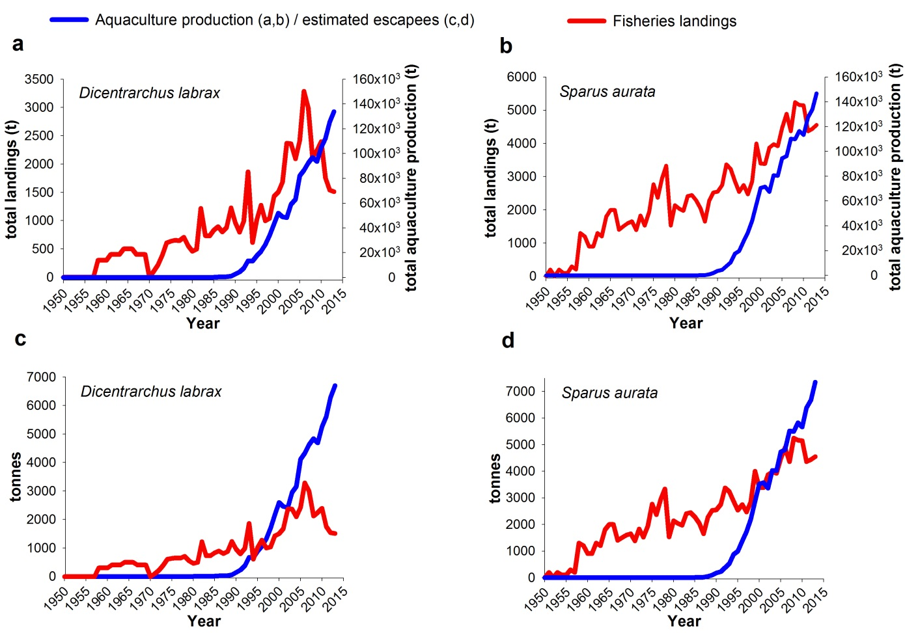

**Fig. 2**

**Fig. 3**